DSP Analysis Report

1. Project Information
Field | Details
Organisation | Darvycom Australia
Project | Darvycom Engineering Laboratory Network and DSP Upgrade
Project stage | Stage II – DSP and Engineering
Network reference | Network 3 – Final Selected Solution
Prepared by | Leonardo Matias Ciarcia – Technical Specialist / Project Manager
Analysis date | 23/02/2026
Location | Darvycom Engineering Laboratory
Document purpose | To analyse the DSP functions of the upgraded network and document the tests conducted using the new devices and software tools.

2. Purpose of the DSP Analysis
The purpose of this analysis was to confirm that the proposed Darvycom network can support digital voice, audio, video-conferencing and DSP-related activities. Testing examined signals in the time and frequency domains, compared linear and logarithmic spectrum displays, applied convolution processes and verified the transmission of voice, video and data through Network 3.
The analysis also evaluated whether the new network devices could provide stable and low-latency communication for the 20 IP phones, video-conferencing system, data servers and engineering laboratory computers.
Testing was conducted using Cisco Packet Tracer, the Academo Spectrum Analyzer, the Academo Virtual Oscilloscope, MATLAB and the proposed PRTG Network Monitor solution.

3. DSP Requirements
The DSP solution was required to:
- Capture and represent analogue audio as a digital signal.
- Display signal amplitude over time.
- identify the frequency components contained in audio signals.
- Compare linear and logarithmic spectrum displays.
- Apply Fourier analysis to convert signals from the time domain to the frequency domain.
- Perform linear and circular convolution.
- Support digital filtering and communication-system simulations.
- Transmit digital voice and video with low delay, jitter and packet loss.
- Prioritise voice and video traffic through VLAN and QoS configurations.
- Allow signal and network performance to be monitored and documented.
- Compare simulated results with expected analytical results.

4. New Devices and Software Tools Used
Device or Tool | Purpose in DSP and Network Testing
Cisco 2911 CME router | Operates as the IP-PBX voice server and manages IP phone registration, extensions and internal calls.
Core Layer 3 switch | Routes voice, data, server, management and video traffic between VLANs.
Managed switches | Connect computers, IP phones, servers and other endpoints while supporting VLAN and QoS configurations.
IP phones | Convert voice into digital packets and reproduce received digital voice signals.
Headsets and microphones | Capture analogue speech and convert it into electrical signals for digitisation and transmission.
Video-conferencing endpoint | Tests real-time digital audio and video communication.
Data servers | Provide storage and network services for the engineering laboratory.
Wireless access points | Provide network access for authorised wireless devices.
Cisco Packet Tracer | Simulates the complete Network 3 topology, VLANs, routing, servers, IP telephony and connectivity.
Academo Spectrum Analyzer | Displays the frequency content of the two recorded audio samples.
Academo Virtual Oscilloscope | Displays audio signals in the time domain and provides a frequency-spectrum view using Fourier analysis.
MATLAB | Performs convolution, filtering, mathematical modelling, plotting and comparison of DSP results.
PRTG Network Monitor | Monitors network utilisation, latency, packet loss, availability and traffic conditions that can affect DSP services.

5. Tests Conducted

5.1 Audio Spectrum Analysis
Test item | Details
Software | Academo Spectrum Analyzer
Input | Audio 1 and Audio 2
Test views | Linear and logarithmic frequency displays
Objective | Identify the frequency components and compare how each display represents strong and weak signal components.
Method | Each audio recording was loaded or captured in the spectrum analyser. The signal was observed first using the linear scale and then using the logarithmic scale. Screenshots were captured for comparison.
Result | Both audio files produced visible frequency components. However, the distribution and intensity of the frequencies were different, confirming that the two recordings had different spectral characteristics.
Status | Test completed successfully

Linear-scale observations
The linear spectrum view emphasised the strongest frequency components in each audio recording. Frequencies with the highest amplitudes were clearly visible, but weaker harmonics and background components were less noticeable because the display provided a smaller visible dynamic range.
This view was useful for identifying the dominant frequencies and comparing the strongest parts of Audio 1 and Audio 2.
Audio 1
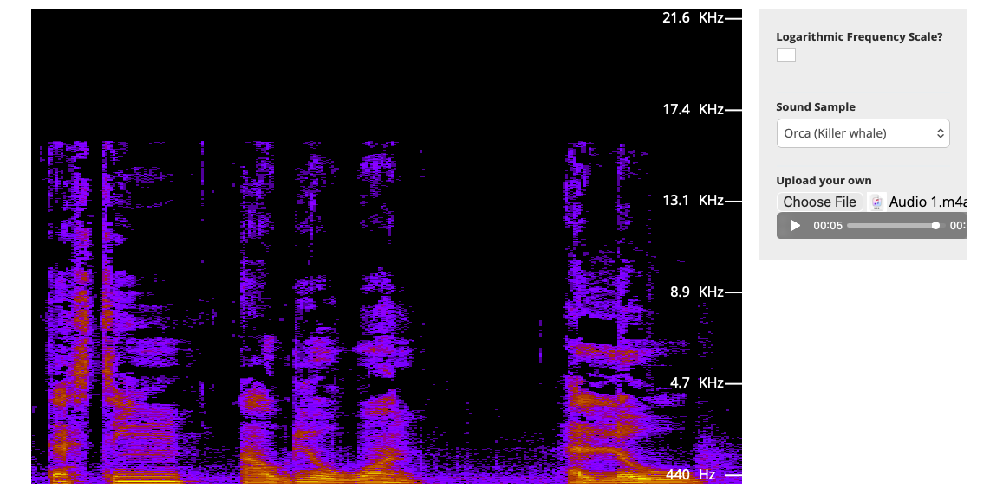
Audio 2
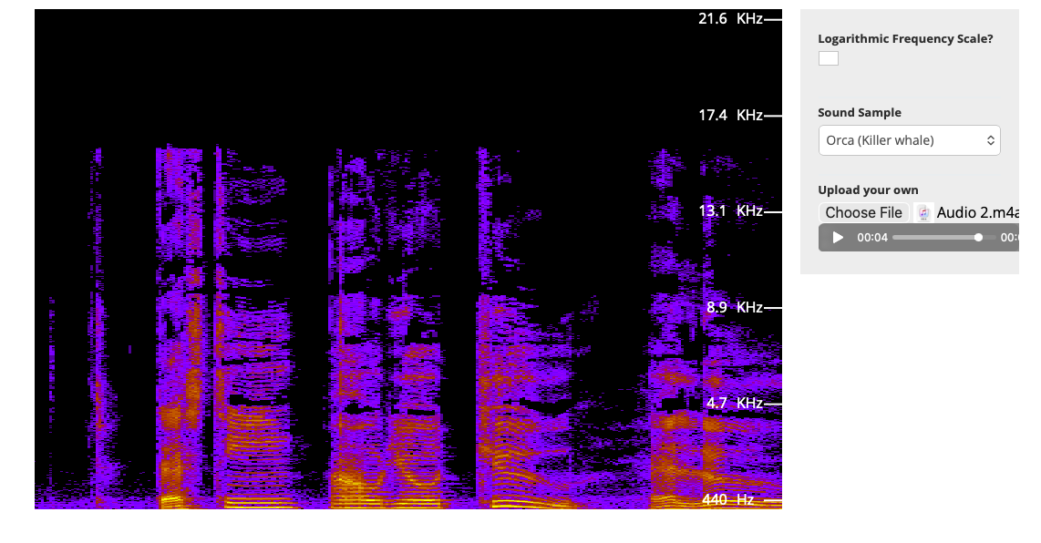

Logarithmic-scale observations
The logarithmic spectrum view made weaker components more visible by representing a wider range of signal amplitudes. Harmonics, lower-level frequencies and background noise that were difficult to see in the linear view became clearer.
The logarithmic view was more suitable for analysing speech and communication signals because their frequency components can have significantly different amplitude levels.
Audio 1
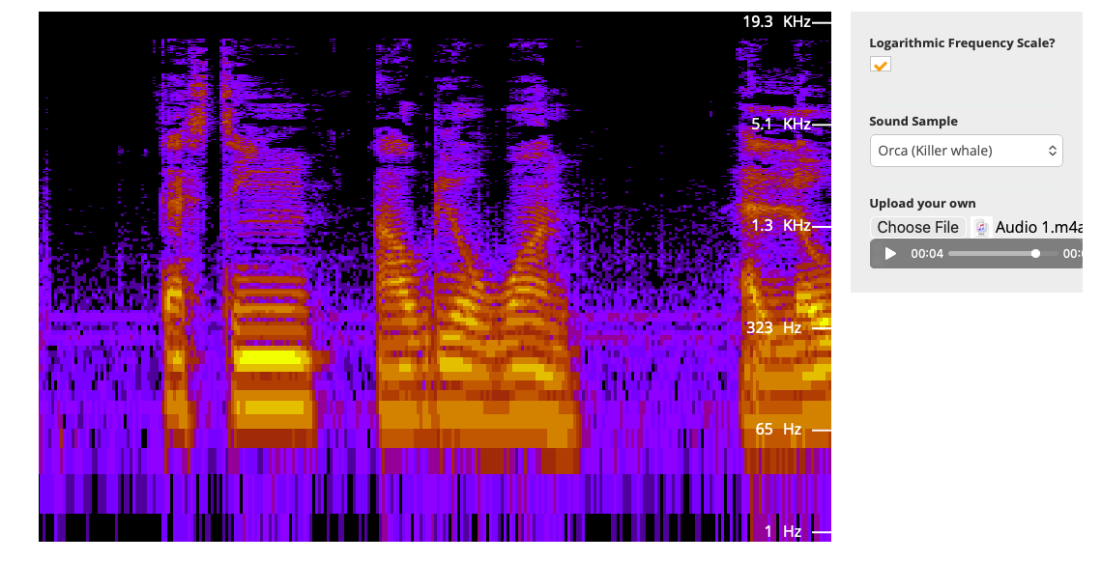

Audio 2
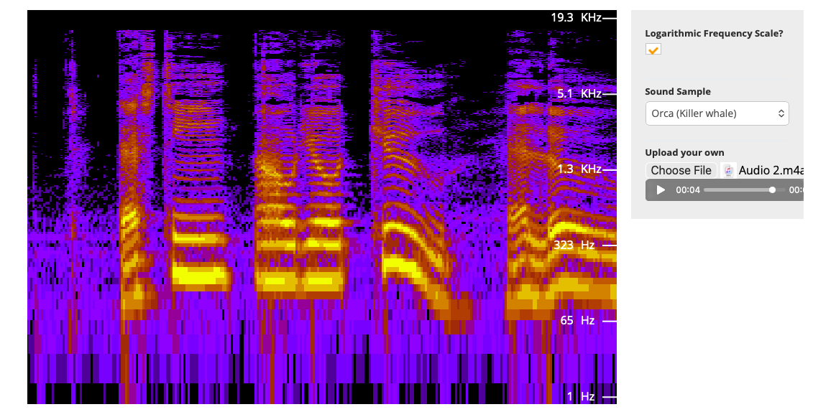

Comparison
Linear Scale | Logarithmic Scale
Highlights the strongest frequency components. | Shows both strong and weak frequency components.
Lower-amplitude harmonics may be difficult to identify. | Lower-amplitude harmonics and noise are easier to observe.
Useful for direct amplitude comparison. | Useful for observing a wide dynamic range.
Strong signals may dominate the display. | Provides more detail across the complete spectrum.
The results demonstrated that the same signal can appear different depending on the scale used. The logarithmic view did not add new frequencies; it made the existing lower-amplitude frequency components easier to identify.

5.2 Time-Domain and Frequency-Domain Analysis
Test item | Details
Software | Academo Virtual Oscilloscope
Input | Microphone audio, uploaded audio or an available preset signal
Objective | Examine how the signal changed over time and compare it with its frequency content.
Method | The audio input was observed as a time-domain waveform. The frequency-spectrum function was then used to examine the signal through Fourier analysis.
Result | The oscilloscope displayed changes in amplitude over time, while the frequency display showed the frequency components contained in the same signal.
Status | Test completed successfully

Analysis
The time-domain display showed the relationship between signal amplitude and time. Higher waveform peaks indicated greater signal amplitude, while repeated patterns indicated periodic or approximately periodic signal behaviour.
The frequency-domain display showed how the signal energy was distributed across different frequencies. Fourier analysis separated the complex audio waveform into its individual frequency components.
The two displays provided different but complementary information. The time-domain waveform was useful for observing duration, amplitude, timing and sudden changes. The frequency-domain display was more useful for identifying dominant frequencies, harmonics, interference and noise.
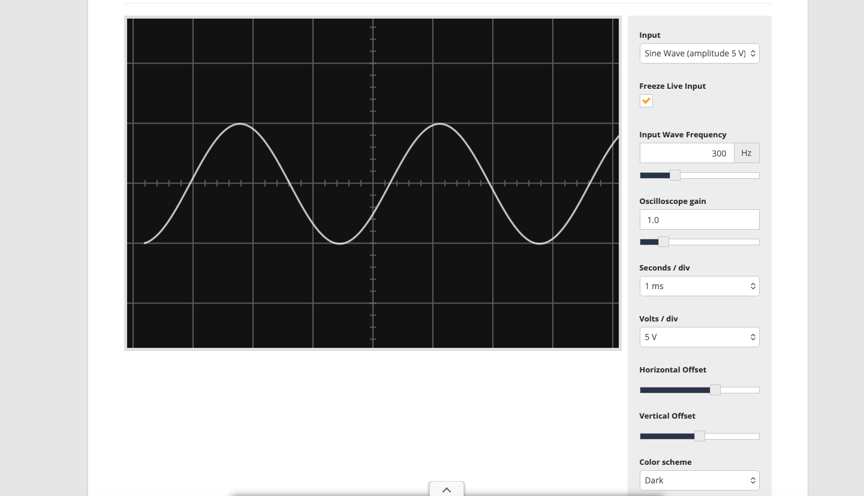

5.3 MATLAB Linear Convolution Test
Test item | Details
Software | MATLAB
Process | Linear convolution using conv(x,h)
Objective | Determine the output produced when an input sequence passes through a discrete-time system with a specified impulse response.
Method | The input sequence and impulse-response sequence were entered into MATLAB. The conv function calculated the output, and the input, impulse response and result were displayed using stem plots.
Expected output length | Length of input + length of impulse response − 1
Result | MATLAB generated the resultant sequence and displayed the input, impulse response and convolution output in three plots.
Status | Test completed successfully

Analysis
Linear convolution was used to represent how a digital signal is modified by a linear time-invariant system. The input sequence represented the original signal, while the impulse response represented the characteristics of the system or filter.
The resulting sequence showed the combined effect of the signal and system. This process is relevant to Darvycom because filtering can be used for noise reduction, echo control, signal shaping and voice-quality improvement.

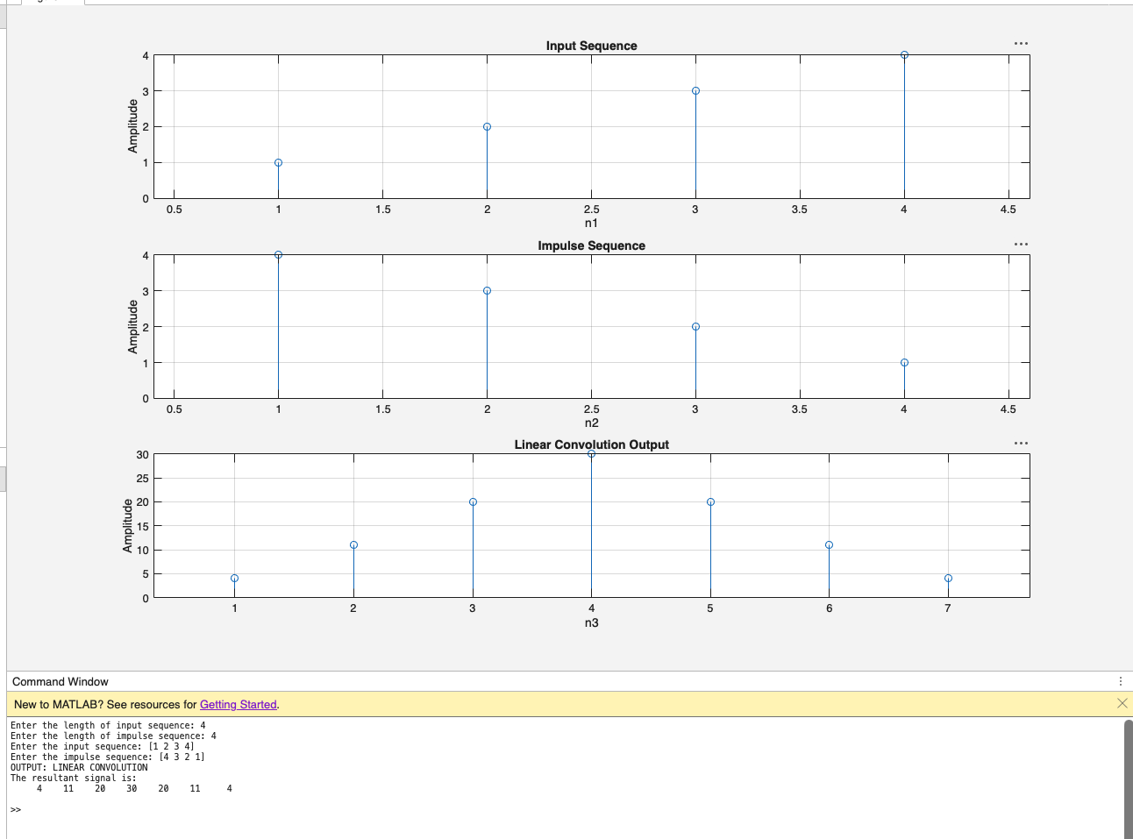

5.4 MATLAB Circular Convolution Test
Test item | Details
Software | MATLAB
Process | Circular convolution
Objective | Analyse the periodic convolution of two discrete sequences.
Method | The two sequences were entered into MATLAB. Their lengths were determined, the required convolution length was selected and the circular convolution output was calculated.
Result | MATLAB produced a periodic output sequence based on the selected convolution length.
Status | Test completed successfully, subject to retaining the output screenshot

Analysis
Circular convolution treats the input sequences as periodic. It is commonly associated with Discrete Fourier Transform processing and frequency-domain calculations.
The circular convolution result may differ from linear convolution when the sequences are not padded sufficiently. Zero-padding both sequences to at least the required linear-convolution length allows circular convolution to produce an equivalent result to linear convolution.
The test demonstrated the relationship between convolution and frequency-domain DSP processing.
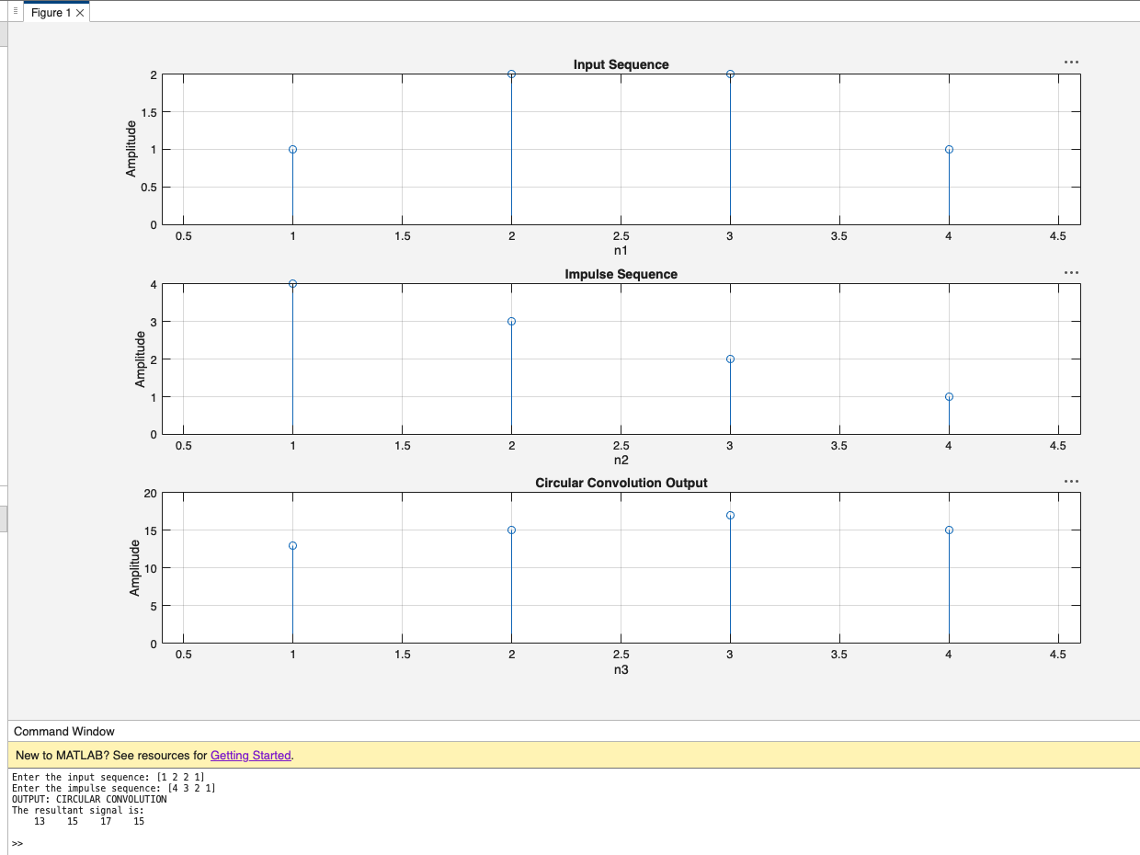

5.5 Cisco CME and IP Telephony Test
Test item | Details
Devices | Cisco 2911 CME router and IP phones
Software | Cisco Packet Tracer
Objective | Confirm that the final Network 3 solution supports digital voice services.
Method | The Server-PT voice server was replaced with a Cisco 2911 because Server-PT did not support the required telephony-service configuration. The CME router was connected to the Core L3 switch and configured to manage IP phones and extensions.
Result | The voice-server connection and configurations were corrected, and the final Network 3 tests were completed successfully.
Status | Successful after corrective action

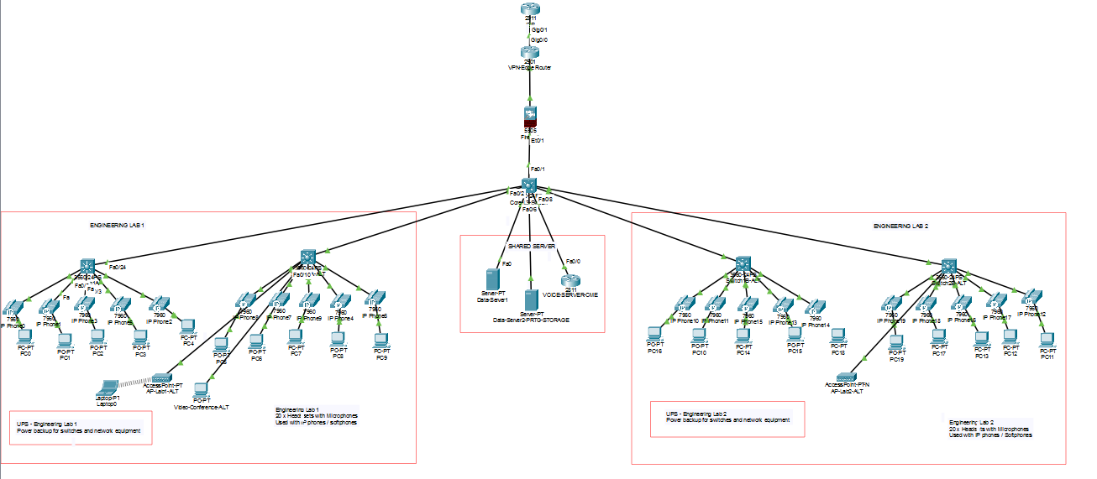

Analysis
The IP phones digitise speech, divide it into packets and transmit it through the voice network. The Cisco 2911 provides the call-control functions needed to register the phones, assign extensions and establish internal calls.
Voice quality depends on network conditions such as latency, jitter, packet loss and congestion. VLAN separation and QoS reduce the likelihood that normal data traffic will interfere with voice communication.

5.6 Network Connectivity and DSP Service Test
Test item | Details
Devices | Core L3 switch, servers, video-conferencing endpoint, computers and access switches
Software | Cisco Packet Tracer
Objective | Confirm that the devices involved in voice, data and video processing can communicate across Network 3.
Test addresses | 10.10.60.10 and 10.10.40.10
Initial result | Some tests timed out and reported packet loss. The video-conferencing and server networks could not initially communicate correctly.
Corrective action | Interface status, VLAN assignments, trunk configuration, default gateways, IP addresses and inter-VLAN routing were reviewed and corrected.
Final result | Connectivity tests were successfully completed after the configurations were corrected.
Status | Successful

Analysis
The initial timeouts demonstrated that DSP services depend on correct network configuration. Even if the audio or video processing works correctly at the endpoint, incorrect VLAN, gateway or routing settings can prevent the processed information from reaching its destination.
Successful communication involving the server at 10.10.60.10 and the video-related endpoint at 10.10.40.10 confirmed that the corrected network could transport the required digital information between the relevant VLANs.

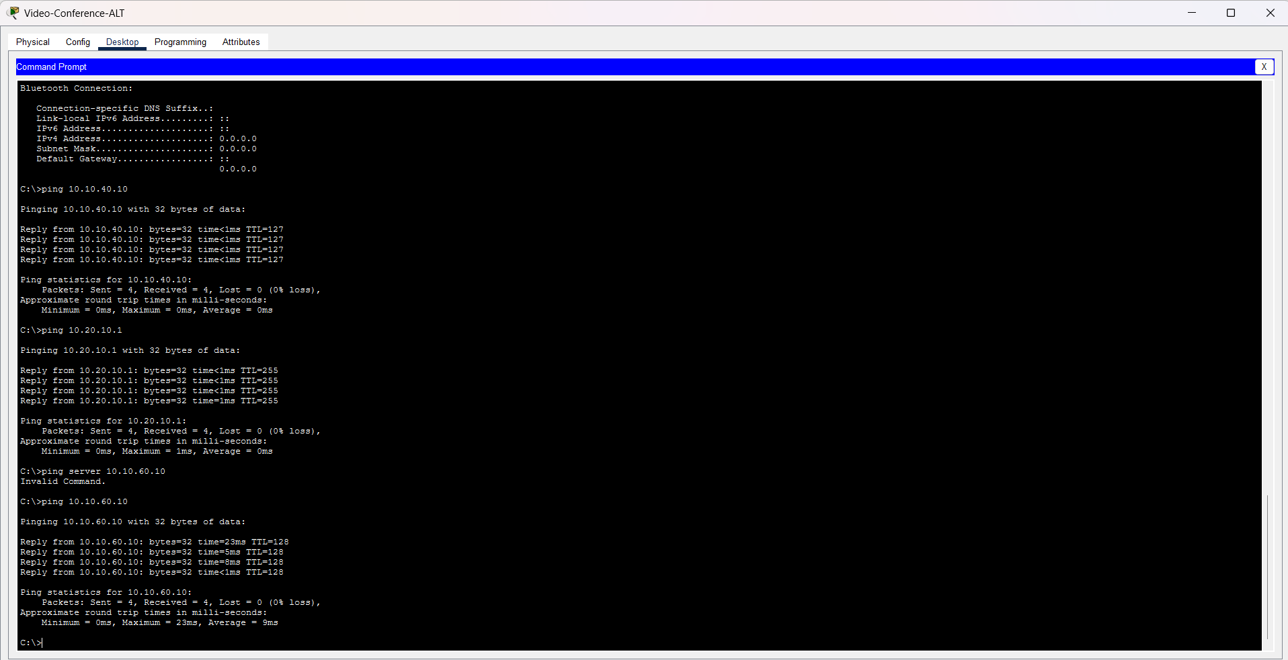
Test Sercer Connectivy at 10.10.60.1: Successful connectivity test from the video-conferencing network to Server1 at 10.10.60.10.
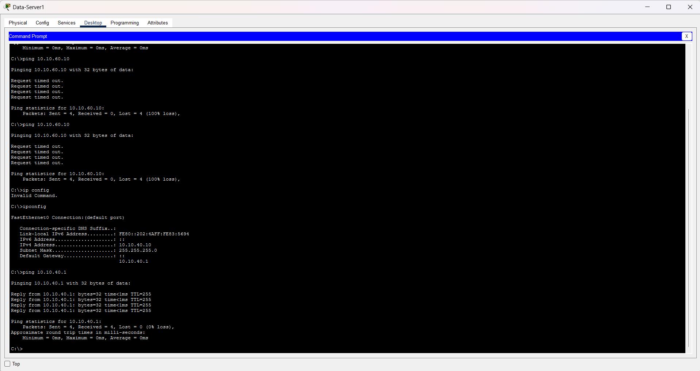
Test Video-Conference connectivity at 10.10.40.1: Successful connectivity test from Server1 to the video-conferencing endpoint at 10.10.40.10.

5.7 VLAN and QoS Test
Test item | Details
Devices | Core L3 switch, managed switches, IP phones and video-conferencing endpoint
Objective | Separate different traffic types and prioritise delay-sensitive communication.
Method | Voice, data, servers, management and video services were allocated to the approved VLAN structure. Trunk links were configured to carry the required VLANs.
Expected result | Devices communicate only through authorised network paths, while voice and video traffic receive priority over ordinary data traffic.
Result | VLAN and routing configurations supported the final successful Network 3 connectivity tests.
Status | Successful

Analysis
VLAN separation reduces broadcast traffic and provides improved control over voice, data, management, server and video traffic. QoS is important for DSP-related communication because voice and video are sensitive to delay and changes in packet arrival time.
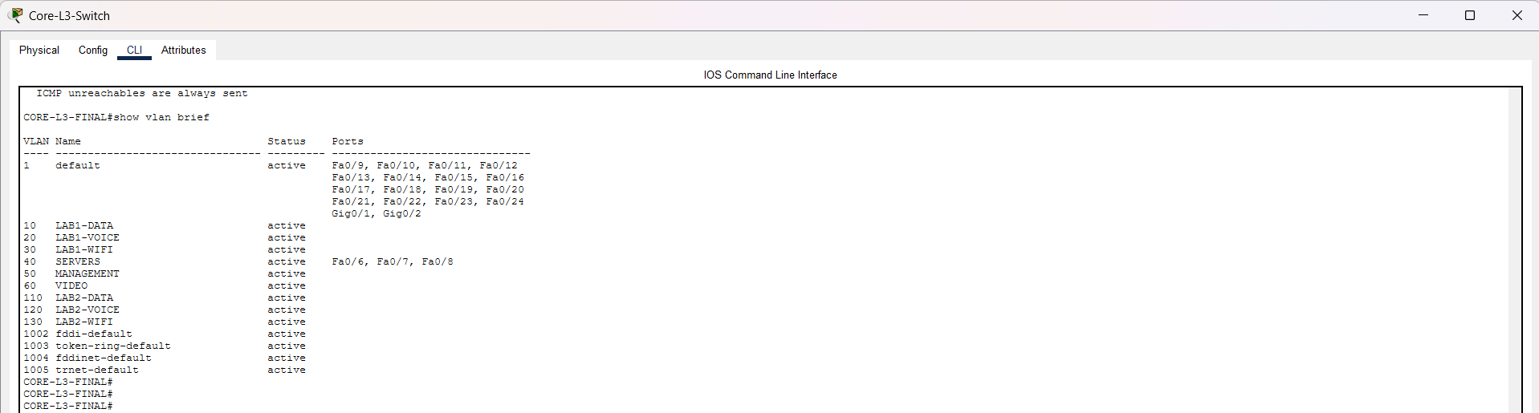
Test VLAN

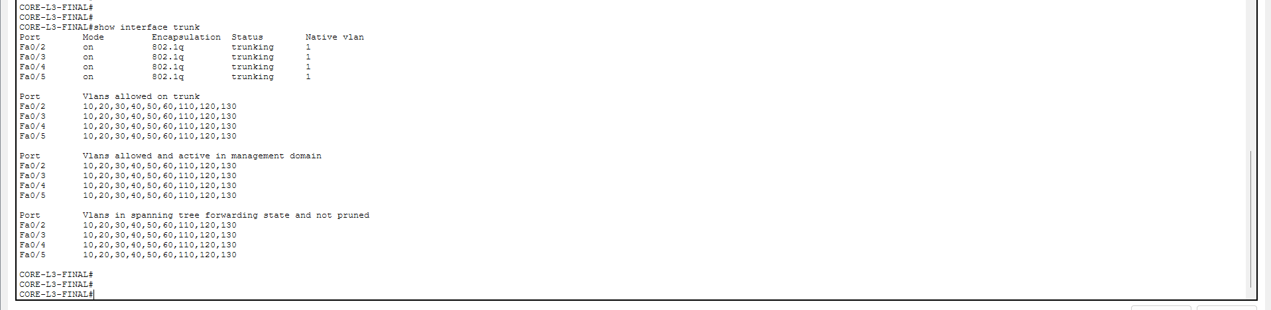

Test Trunk Configuration
Without QoS, large data transfers could create congestion and reduce call or video quality. Prioritising real-time traffic helps maintain clear voice, synchronised video and consistent communication performance.

5.8 PRTG Monitoring Test
Test item | Details
Software | PRTG Network Monitor
Objective | Monitor network conditions that can affect VoIP, video conferencing and DSP services.
Recommended sensors | Ping, bandwidth, traffic utilisation, device availability, packet loss, latency and interface status
Expected result | PRTG identifies performance degradation before it causes a significant voice or video service failure.
Evidence status | Include this test only if a PRTG dashboard or sensor screenshot was captured. Otherwise, describe it as a planned monitoring test.

Analysis
PRTG supports the DSP solution by monitoring the transport network rather than processing the audio signal itself. High latency, packet loss, interface errors and congestion can reduce the quality of processed voice and video.
Alerts should be configured so the technical team is notified when performance exceeds the approved thresholds. Historical PRTG data can also be used for capacity planning and identifying recurring traffic problems.

Bandwidth test
- Sensor: Packet Sniffer
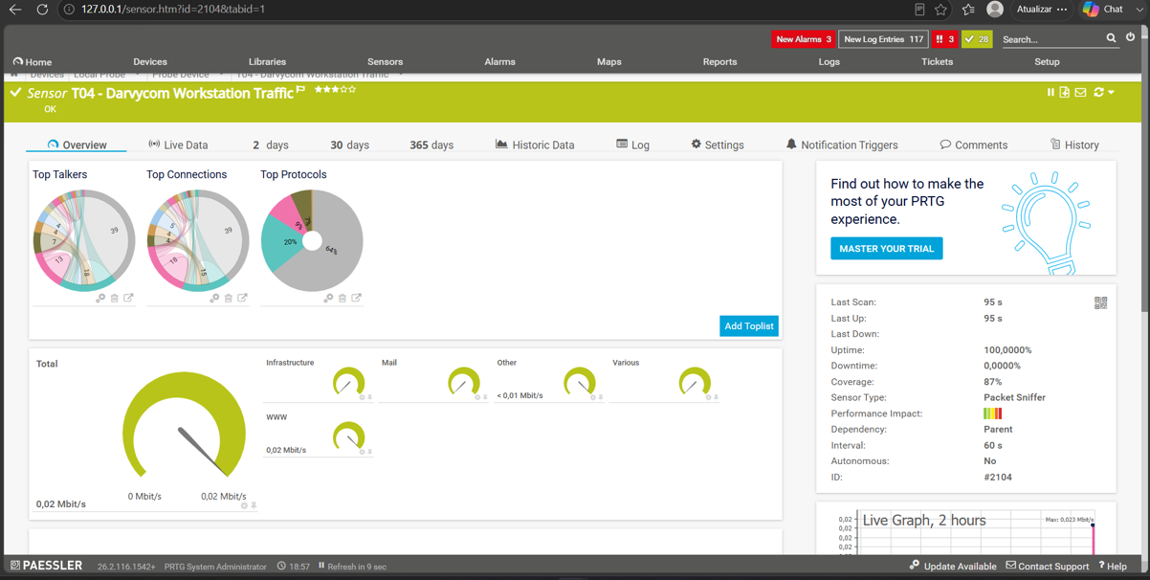
- Increased workstation traffic during simulated video and data usage.
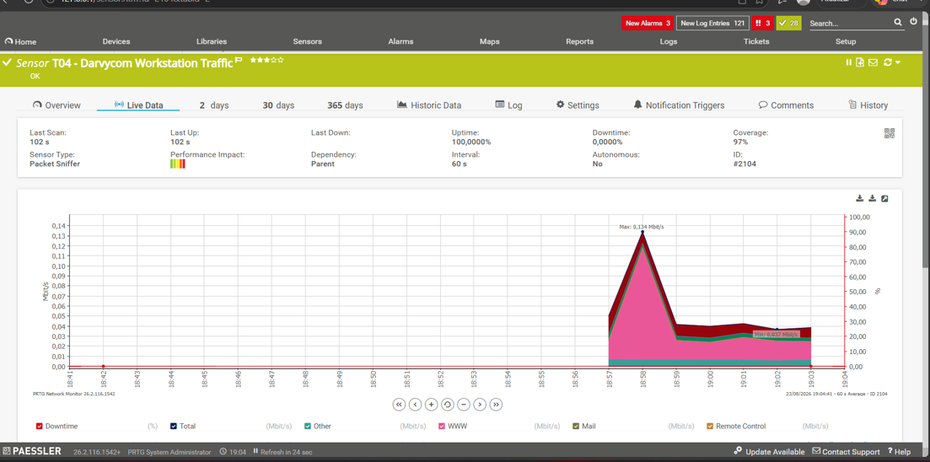
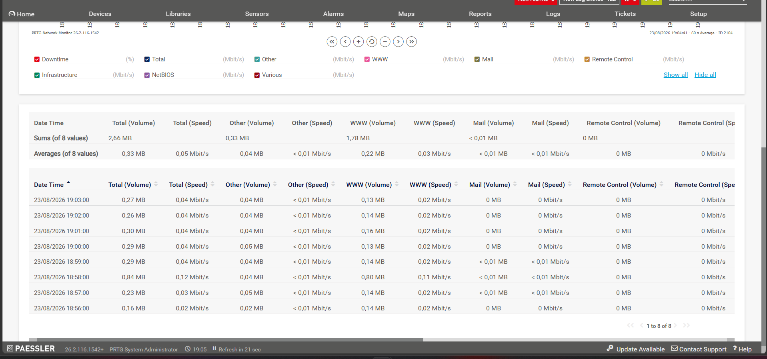

Packet Loss Test
- Sensor Down
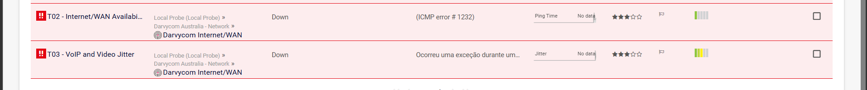

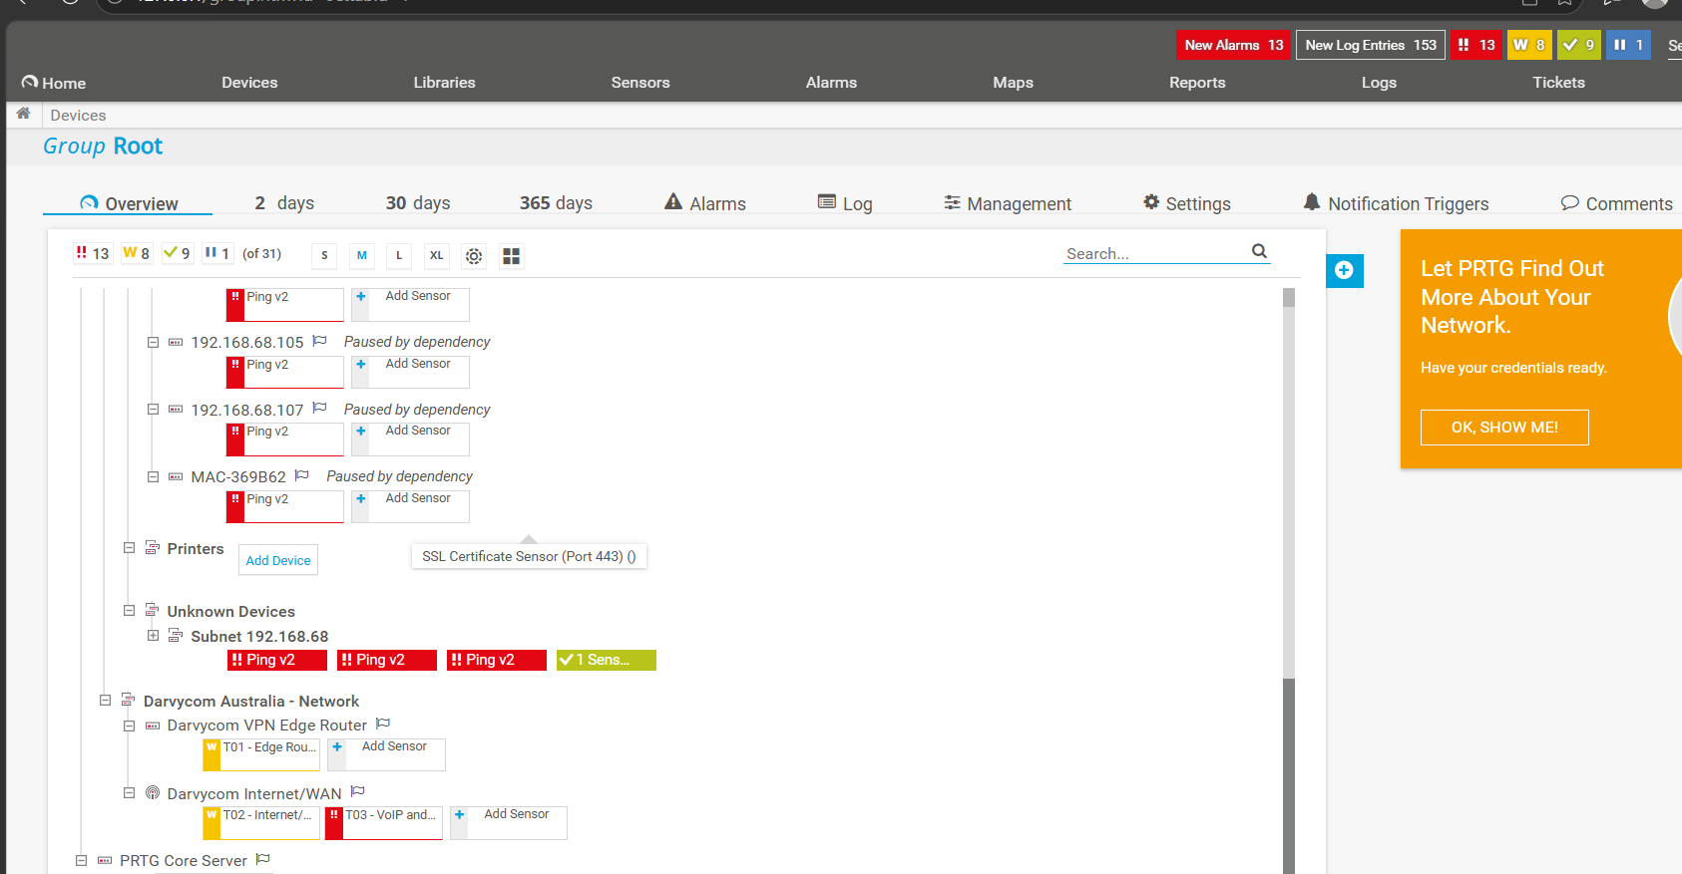

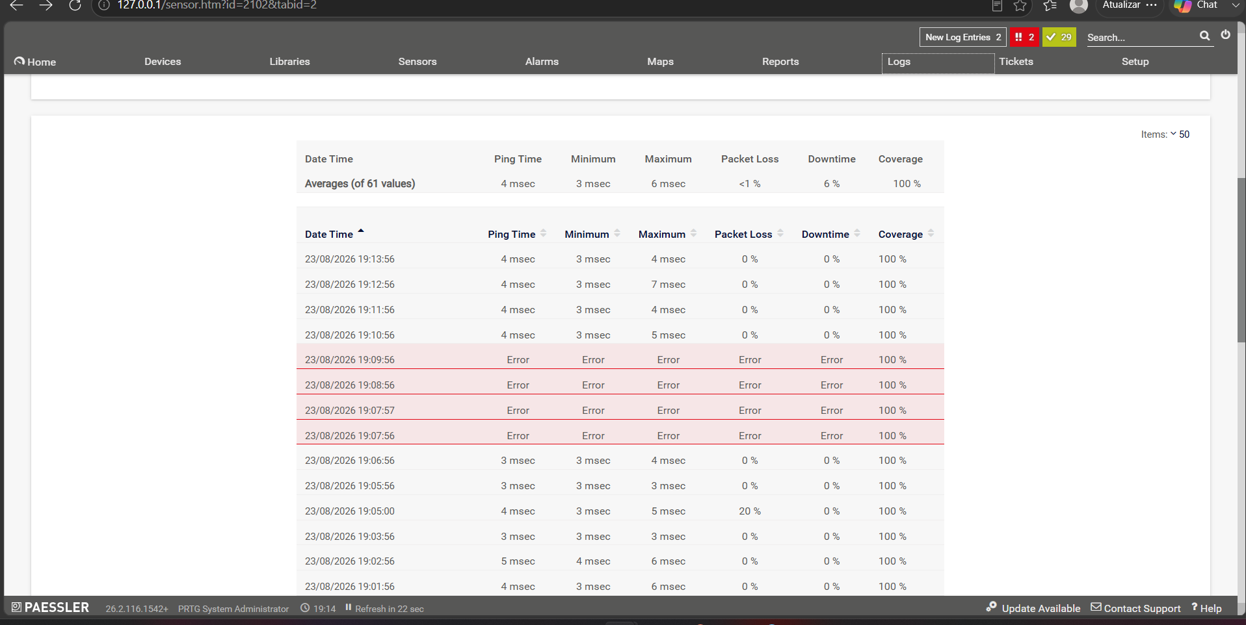

-Sensor Up
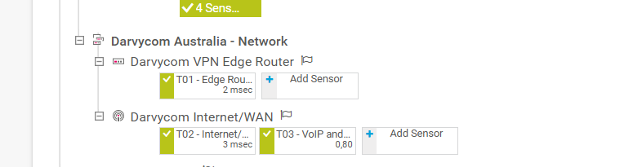

6. Problems Identified and Corrective Actions
Problem | Cause | Corrective Action | Final Outcome
telephony-service command was not recognised | Server-PT did not provide Cisco CME functionality | Server-PT was replaced with a Cisco 2911 router | CME/IP-PBX functions could be configured
Voice-server connection displayed red | Interface or physical connection was not operational | Cable connection and interfaces were checked and enabled | Link became operational
Core L3 Fa0/8 was down | Interface configuration or connection required correction | Interface configuration and status were reviewed | Voice server communicated with the core network
Tests returned timeouts and 100% packet loss | VLAN, gateway, trunk or routing configuration was incomplete | IP addressing, VLANs, trunks and routing were corrected | Final connectivity tests succeeded
Server connectivity failed at 10.10.60.10 | Network path was initially incomplete | Server addressing and inter-VLAN communication were reviewed | Server became reachable
Video-network connectivity failed at 10.10.40.10 | Video endpoint or VLAN could not initially reach other networks | Gateway, VLAN and routing settings were corrected | Video-related connectivity succeeded
Weak spectrum components were difficult to observe | Linear display showed a limited visible dynamic range | Logarithmic spectrum view was used | Weak harmonics and background components became clearer

7. Overall DSP Analysis
The tests demonstrated that the Darvycom solution supports the main DSP processes required by the project. The Academo tools provided visual analysis in the time and frequency domains. MATLAB demonstrated convolution and digital-system behaviour. Cisco Packet Tracer confirmed that the new network could transport digital voice, video and data between the required devices and VLANs.
The initial failures were mainly associated with device selection and network configuration rather than the DSP algorithms. Replacing Server-PT with a Cisco 2911 provided the necessary IP-PBX functions. Correcting interface, VLAN, gateway, trunk and routing configurations resolved the connectivity failures.
The final Network 3 solution provides a suitable platform for voice processing, video conferencing, server communication and engineering DSP activities. Continued PRTG monitoring is recommended to identify latency, congestion, packet loss and availability problems that could affect signal quality.

8. Conclusion
The DSP and network tests were completed using the new Darvycom devices and software tools. The results demonstrated the difference between time-domain and frequency-domain analysis, the advantages of logarithmic spectrum representation, the use of linear and circular convolution and the importance of reliable network transport for digital voice and video.
Following the corrective actions, the Cisco 2911 voice server, Core L3 switch, servers, video-conferencing endpoint and other Network 3 components communicated successfully. The selected solution therefore meets the main DSP, voice, data and video requirements of the Darvycom Australia project.

